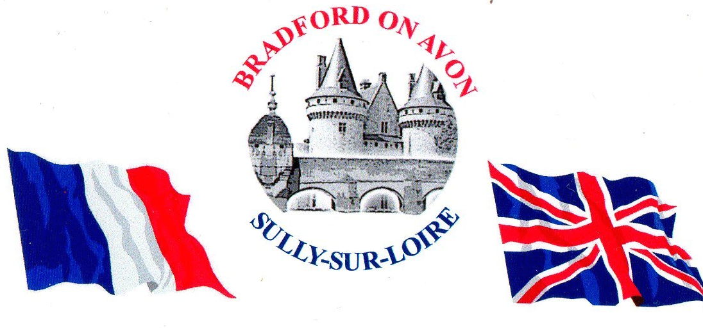

Sully-sur-Loire
Bradford on Avon’s twin town, Sully-sur-Loire, is situated on the banks of the beautiful river Loire and within easy reach of many historic towns and villages. Sully has its own magnificent chateau from the 13th century set in a park of open country and woodlands. Besides tours and exhibitions, there are firework displays and events during July and August. Sully has a lively social life and is known for its music festival, its good food and its welcoming people. The area around Sully offers something for everyone: art exhibitions, sport, walking, cycling, golf, boat trips, museums…
The town has a wide variety of interesting shops, cafes and restaurants and on Mondays a wonderful market in the centre of town. For more information about Sully, go to:
www.sully-sur-loire.fr

The Twinning Association
The Association fosters friendship between Bradford and Sully and encourages visits, by individuals and groups, to and from the two towns. These exchanges have taken place for more than 30 years and many friendships have been formed (even a marriage!)
Visits last about three to five days and we usually stay in each other’s homes. There are trips to places of interest, joint activities and meals together. If you enjoy meeting people and new experiences then twinning is for you! You certainly don’t need good French although a few words would help.

Membership of the Association is open to all. Besides the exchanges, there is a programme of social events here in Bradford throughout the year. If you would like to come along to an event, please contact us at email boafta@outlook.com

Find out more at:
www.bradfordonavonfrenchtwinning.weebly.com

You can download our Constitution and a Membership form from the Join page.

Membership application form 2023

To become a member, please fill in this form and email it to boafta@outlook.com Or send with payment to: Hon Treasurer: BoAFTA, c/o 19B Frome Road, Bradford on Avon BA15 2EA.
Applications are tabled at the next convenient meeting of the Association’s Committee.

I/we subscribe to and are in sympathy with the aims
of the Association, as set out in its Constitution. YES/NO ........

NAME(S) ……………………………………………………………………………..........…

……………………………………………………………………………............

ADDRESS ………………………………………………………………………………….......

…………………………………………… POST CODE.....................

TEL NO …………………………………….......

MOBILE NO(S) …………………………………….......

…………………………………….......

EMAIL(S) ……………………………………. …………………………………….

…………………………………… …………………………………….

Single (£10) or Family* (£20)? …………....
* A "family" is all persons living together as a family at the same address. This can include live-in guests such as refugees from Russia’s invasion of Ukraine.

Please pay online if possible. Details of our Lloyds Bank business account:
Name: B-on-A & Dist French Twinning Assn.
Sort code 30 98 75, Account number 01233758.
Add a reference made up of: initial, surname and 2023, e.g. "JSMITH2023".

Privacy Statement. In sending us this information, you are consenting to us holding it electronically and/or on paper, for the purposes of running the organisation (information on future events, meetings or newsletter for example), with access restricted to officers of the Association only, and for only as long as is necessary and appropriate.

Simon Kay, Chair
John Spence, Hon. Treasurer
Andrew Nicolson, Hon. Secretary
Alex Kay, Town Councillor

